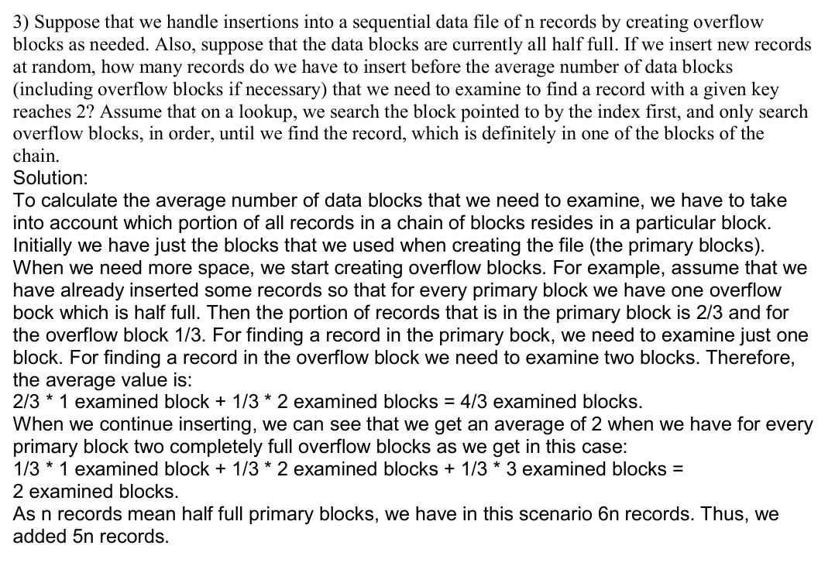

This problem involves calculating how many additional records need to be inserted into a sequential data file with overflow blocks until the average number of data blocks examined during a lookup reaches 2. Here's a detailed explanation of the solution:

Key Concepts
- Primary Blocks and Overflow Blocks:
  - Primary Block: These are the original blocks in the file. Initially, they are half full with records.
  - Overflow Block: When primary blocks fill up, overflow blocks are created to store excess records.
- Lookup Process:
  - Lookups always start by examining the primary block linked to the given key.
  - If the record is not found in the primary block, overflow blocks are searched sequentially.
- Average Number of Blocks Examined:
  - The average is calculated as a weighted sum, considering:
    - The proportion of records stored in each block type (primary vs. overflow).
    - The number of blocks that must be examined to access the records.

Steps in the Solution
- Initial Condition: Half-Full Primary Blocks:
  - The problem assumes the file starts with n primary blocks that are half full.
  - Thus, the file contains n/2 records initially.
- Adding Overflow Blocks:
  - As more records are inserted, primary blocks fill up, and overflow blocks are created.
  - Records are distributed between the primary block and overflow blocks, affecting the average number of blocks examined.

Step-by-Step Analysis
Step 1: One Overflow Block (Half Full)
- Assume one overflow block is created for every primary block, and it is half full.
- Distribution of records:
  - 2/3 of the records are in the primary block.
  - 1/3 of the records are in the overflow block.
- Blocks examined during a lookup:
  - If the record is in the primary block, 1 block is examined.
  - If the record is in the overflow block, 2 blocks (primary + overflow) are examined.
- Average number of blocks examined:

At this point, the average is 4/3 blocks, which is less than 2.

Step 2: Two Completely Full Overflow Blocks
- Now, two overflow blocks are added for each primary block, and both are completely full.
- Distribution of records:
  - 1/3 of the records are in the primary block.
  - 1/3 of the records are in the first overflow block.
  - 1/3 of the records are in the second overflow block.
- Blocks examined during a lookup:
  - Primary block: 1 block is examined.
  - First overflow block: 2 blocks are examined.
  - Second overflow block: 3 blocks are examined.

- Average number of blocks examined:

At this point, the average is exactly 2 blocks.

Step 3: Number of Records Inserted
- Initially, there are n/2n / 2n/2 records in the half-full primary blocks.
- At this stage, the file has:
  - nnn records in the primary blocks (now completely full).
  - 2n2n2n records in the two overflow blocks (both completely full).
- Total records:
Total records=n+2n=3n.\text{Total records} = n + 2n = 3n.Total records=n+2n=3n.
- Total records inserted:
Inserted records=3n−n2=6n−n2=5n.\text{Inserted records} = 3n - \frac{n}{2} = \frac{6n - n}{2} = 5n.Inserted records=3n−2n​=26n−n​=5n.
Thus, 5n records are inserted to reach an average of 2 blocks examined.

Summary of the Solution
- Average Blocks Examined:
  - 4/3 blocks for 1 overflow block (half full).
  - 2 blocks for 2 overflow blocks (fully filled).
- Number of Records:
  - Initial: n/2 records.
  - Final: 3n records (2 overflow blocks per primary block).
- Additional Records Inserted: 5n.
The solution combines concepts of record distribution, overflow block creation, and weighted averages to determine the number of insertions needed for the desired lookup efficiency.

the exact same question but only: If we insert new records at random, how many records do we have to insert before the average number of data blocks (including overflow blocks if necessary) that we need to examine to find a record with a given key reaches 3?
ChatGPT:
ChatGPT
To determine how many records need to be inserted until the average number of blocks examined reaches 3, we extend the reasoning in the original solution. Here's a detailed explanation:

Understanding the Question
We aim to calculate how many records must be inserted into a file with n primary blocks (initially half full) so that the average number of blocks examined during a lookup reaches 3.
- Primary Blocks and Overflow Blocks:
  - Initially, the n primary blocks are half full, containing n/2n/2n/2 records.
  - Overflow blocks are created when more records are inserted.
- Average Blocks Examined:
  - For every lookup, we search:
    - The primary block first.
    - Then, any linked overflow blocks sequentially until the record is found.
- Goal:
  - Find the point where the average number of blocks examined reaches 3.

Step-by-Step Solution
Step 1: When Two Overflow Blocks Are Full
From the earlier solution, when each primary block has two fully filled overflow blocks, the average number of blocks examined is:
Average=13×1+13×2+13×3=2.\text{Average} = \frac{1}{3} \times 1 + \frac{1}{3} \times 2 + \frac{1}{3} \times 3 = 2.Average=31​×1+31​×2+31​×3=2.
At this point, the average number of blocks is 2, which is less than the target value of 3. Therefore, more overflow blocks need to be filled.

Step 2: When Three Overflow Blocks Are Full
- Distribution of Records:
  - 1/41/41/4 of the records are in the primary block.
  - 1/41/41/4 of the records are in the first overflow block.
  - 1/41/41/4 of the records are in the second overflow block.
  - 1/41/41/4 of the records are in the third overflow block.
- Blocks Examined During Lookup:
  - Primary Block: 111 block examined.
  - First Overflow Block: 222 blocks examined.
  - Second Overflow Block: 333 blocks examined.
  - Third Overflow Block: 444 blocks examined.
- Average Number of Blocks Examined:
Average=14×1+14×2+14×3+14×4=3.\text{Average} = \frac{1}{4} \times 1 + \frac{1}{4} \times 2 + \frac{1}{4} \times 3 + \frac{1}{4} \times 4 = 3.Average=41​×1+41​×2+41​×3+41​×4=3.
At this stage, the average number of blocks examined reaches 3.

Step 3: Total Number of Records
- Initial Records:
  - Initially, the primary blocks are half full with n/2n/2n/2 records.
- Records in Primary Blocks:
  - After filling the primary blocks, they contain nnn records.
- Records in Overflow Blocks:
  - Each overflow block can hold as many records as a primary block.
  - With 3 overflow blocks per primary block:
    - Total records in overflow blocks: 3n3n3n.
- Total Records:
Total records=Records in primary blocks+Records in overflow blocks=n+3n=4n.\text{Total records} = \text{Records in primary blocks} + \text{Records in overflow blocks} = n + 3n = 4n.Total records=Records in primary blocks+Records in overflow blocks=n+3n=4n.
- Inserted Records:
Inserted records=Total records−Initial records=4n−n2=8n−n2=7n2.\text{Inserted records} = \text{Total records} - \text{Initial records} = 4n - \frac{n}{2} = \frac{8n - n}{2} = \frac{7n}{2}.Inserted records=Total records−Initial records=4n−2n​=28n−n​=27n​.
Thus, 3.5n3.5n3.5n (or 7n/27n/27n/2) additional records must be inserted to reach an average of 3 blocks examined.

Final Answer
To achieve an average of 3 blocks examined, 3.5n3.5n3.5n records must be inserted.

To determine how many records must be inserted into a sequential data file to make the average number of blocks examined during a lookup reach 4, we proceed as follows:

Understanding the Setup
- Primary Blocks:
  - We start with n primary blocks, each initially half full.
  - Each block can hold a certain number of records, but overflow blocks are created as new records are inserted.
- Overflow Blocks:
  - Overflow blocks are linked to the primary blocks.
  - Lookups are performed sequentially: the primary block is searched first, followed by the overflow blocks in the order they were added.
- Average Number of Blocks Examined:
  - For every lookup, we calculate the weighted average of the blocks examined, based on how many records are in each block and their positions in the chain.
- Goal:
  - Determine the number of records to insert such that the average number of blocks examined reaches 4.

Step-by-Step Solution
Step 1: Analyze Blocks and Records Distribution
When kkk overflow blocks are linked to each primary block:
- Each primary block holds a fraction of the records.
- Overflow blocks progressively hold the remaining records.
- The average number of blocks examined is calculated as:
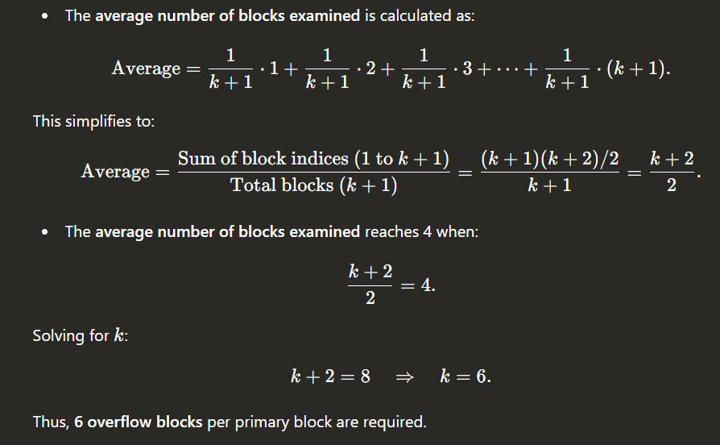

Thus, 6 overflow blocks per primary block are required.

Step 2: Calculate Total Records
- Records in Primary Blocks:
  - Each primary block holds n/2 records initially (as the blocks are half full).
  - After filling, the primary blocks contain n records.
- Records in Overflow Blocks:
  - Each overflow block can hold as many records as a primary block.
  - With 6 overflow blocks per primary block:
Total records in overflow blocks=6n
- Total Records in File:
  - Records in primary blocks + Records in overflow blocks:
Total records = n+6n=7n
- Inserted Records:
  - Initially, the primary blocks were half full with n/2 records.
  - Records inserted = Total records - Initial records:
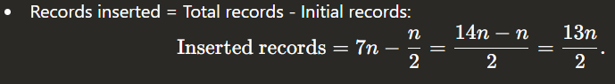

Final Answer
To reach an average of 4 blocks examined, 6.5n (or 13n/2 ​) records must be inserted.

